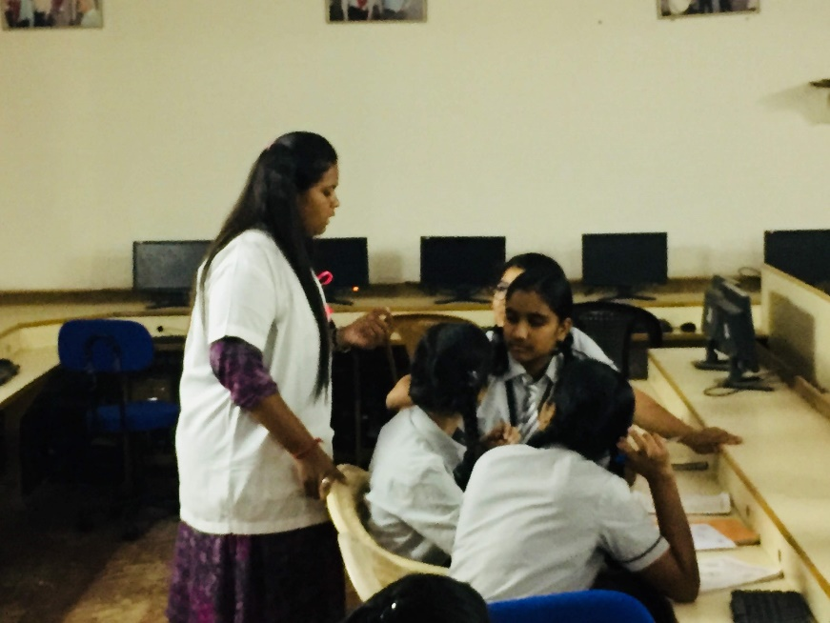

Figure 1 Explaining about Breast cancer

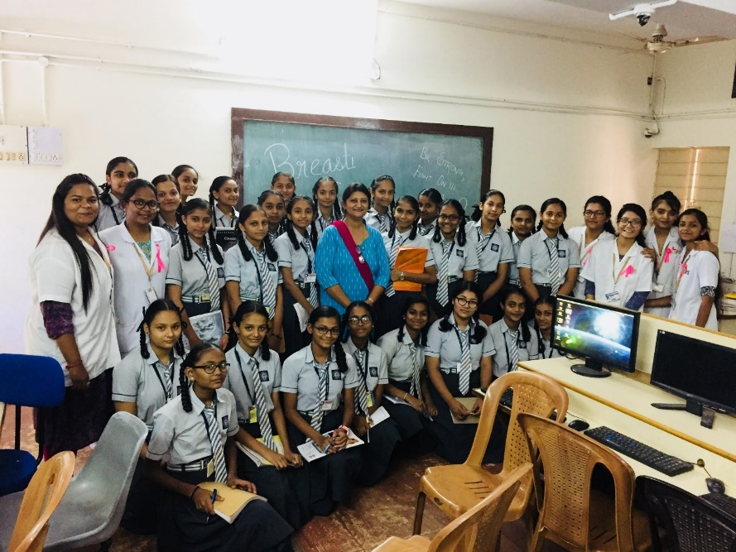

Figure 2- Group picture with students and teachers in C.J Patel, Vir Vitthal and Sardar Patel School, Karamsad

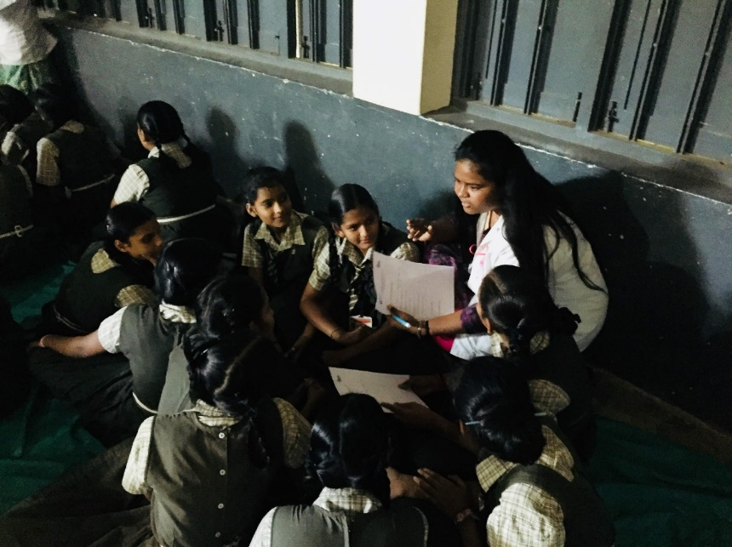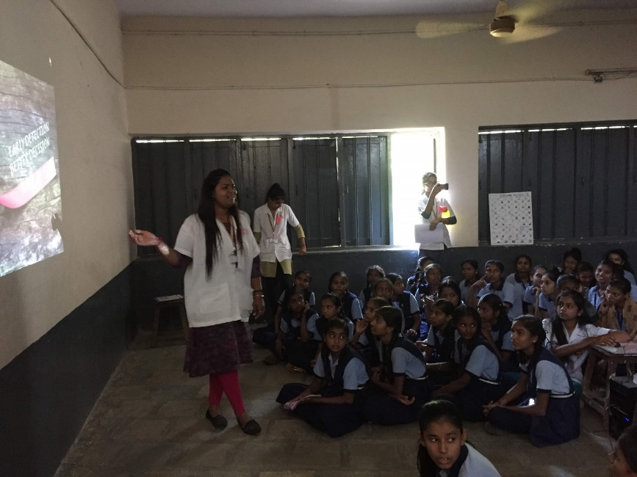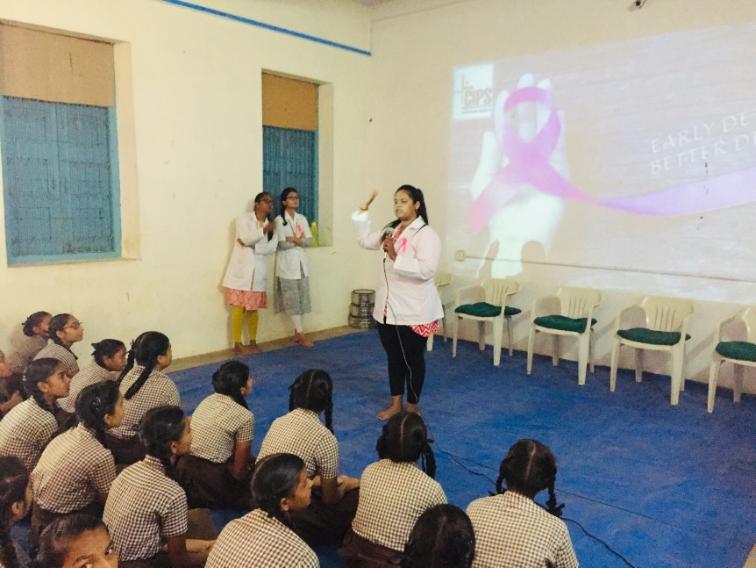

Figure 3 – Breast cancer awareness among students in B.A Patel High school.

Figure 4 – Oral presentation using projector and demonstration of self-breast awareness in NL Patel High School, Napad.